Delete node in a linked List:
Problem Statement: Given a linked list, delete the tail of the linked list and print the updated linked list.
Examples

Example 1:

Examples:

Input Format: 0->1->2

Result: 0->1

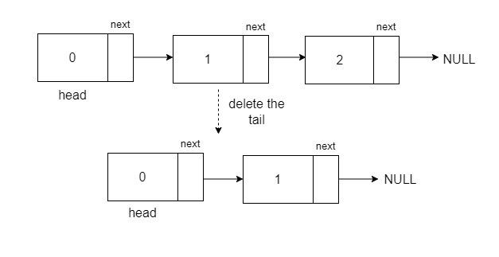
Explanation: The tail of the list is the last node. After removing the tail, and updating the linked list, this result is what we get.

Solution
Approach:
The main intuition is to point the second last node to null to get the updated linked list. Hence, we will iterate till the second last node and make it point to NULL. This will effectively skip the last node of the list therefore, we will free up the memory being occupied by this node (Only in the case of C++).
Two edge cases to consider are:
- If the input linked list is empty, we return null.
- If there is only one node in the list, that node itself will be the tail, therefore we return null after deleting that node.
Algorithm:
- Start by initializing a pointer to the head of the list that will be used to iterate through the linked list. Iterate up to the second last node, this node will be our new tail of the list.
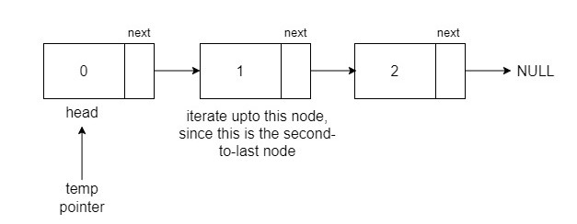
- After reaching the second-to-last node, free up the memory occupied by the former tail or the last node of the list.
Note: In the case of languages like Java, Python, and Javascript, there is no need for the deletion of objects or nodes because these have an automatic garbage collection mechanism that automatically identifies and reclaims memory that is no longer in use.
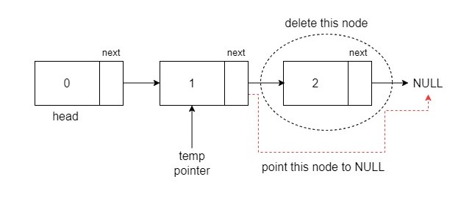
- Finally, point the second last node or the new tail to NULL to obtain the updated linked list.
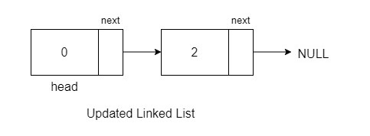
C++
/**
* Definition for singly-linked list.
* struct ListNode {
* int val;
* ListNode *next;
* ListNode(int x) : val(x), next(NULL) {}
* };
*/
class Solution {
public:
void printLL(ListNode* head) {
while (head != NULL) {
cout << head->val << " ";
head = head->next;
}
}

void deleteNode(ListNode* node) {
if (node == NULL || node->next == NULL)
return;
// Copy next node’s data and delete it
ListNode* temp = node->next;
node->val = temp->val;
node->next = temp->next;
delete temp;
}
};

Java:-
/**
* Definition for singly-linked list.
* public class ListNode {
* int val;
* ListNode next;
* ListNode(int x) { val = x; }
* }
*/
class Solution {
public void printLL(ListNode head) {
while (head != null) {
System.out.print(head.val + " ");
head = head.next;
}
}
public void deleteNode(ListNode node) {
if (node == null || node.next == null)
return;
node.val = node.next.val;
node.next = node.next.next;
}
}
Time Complexity: O(N) for traversing the linked list and updating the tail.
Space Complexity: O(1), as we have not used any extra space.

